The Cape Sea urchin *Parachinus angulosus,* a potential new market product for South African aquaculture?

********

Aimee Cloete

Supervisor (s):

Prof John J. Bolton (Emeritus Professor)

Dr Marissa Brink-Hull (UCT Postdoctoral Research Fellow)

Dr Brett M. Macey (DFFE)

Minor Dissertation submitted in partial fulfilment of the requirements for the degree of Master of Science in Applied Ocean Science

Department of Biological Sciences

University of Cape Town

Rondebosch, Cape Town

South Africa 7701

# **Declaration**

I declare that this project is my own, unaided work and has not been previously submitted, in whole or in part, for the award of any degree. Where use has been made of the research of others, it has been duly acknowledged in the text. This project is carried out under the supervision of Dr Marissa Brink-Hull, Dr Brett Macey and Professor John Bolton Department of Biological Sciences, University of Cape Town.

________________________

Aimee Cloete

Department of Biological Sciences, University of Cape Town

# **Acknowledgements**

I would like to acknowledge the All Atlantic Ocean Sustainable, Profitable and Resilient Aquaculture (ASTRAL) project, Dr Marissa Brink-Hull, Dr Brett Macey and Professor John Bolton for the provision of samples, use of facilities and supervision of the project. This project has received funding from the European Union’s Horizon 2020 research and innovation programme under grant agreement No 863034. Dr Brett Macey has ensured that this project has been approved by the Aquaculture Animal Ethics Committee (AAEC) in Fisheries Branch of the Department of Environment, Forestry and Fisheries (DEFF) under project approval No 20210224_su_03_Macey.

(acknowledgement of family, friends etc who have assisted..)

# **Abstract**

Integrated multi-trophic aquaculture (IMTA) systems recycle nutrients from uneaten feed and excreted waste of fed species as food for extractive species (FAO, 2022). The extractive species in IMTA systems are both traded as a commodity and used as a biofiltration system, which increases their value to the farm, this is especially important for extractive species with low commercial value or species which are new entrants to the market. The implementation of IMTA systems can increase the efficiency of aquaculture systems and contribute to the development of a sustainable aquaculture industry, particularly when species that are ecologically compatible are co-cultured (Kang et al. 2003; Kim et al. 2015).

(will start on this after discussion is complete)

# **Contents**

**Declaration** 1

**Acknowledgements** 2

**Abstract** 3

**Contents** 4

**List of figures and tables** 6

**List of acronyms** 7

**1.** **Introduction** 8

1.1. Global aquaculture 8

1.2. African and South African aquaculture 9

1.1. Research aim and objectives 11

**2.** **Literature review** 12

**3.** **Materials and methods** 13

3.1. Ethics statement 13

3.2. Sea urchin collection 13

3.3. Experimental setup 13

3.4. Data collection 15

*3.4.1.* *Somatic growth and feed conversion ratio* 15

*3.4.2.* *Gonad quality and development* 15

3.5. Statistical Analyses 16

**4.** **Results** 17

**5.** **Discussion** 20

**6.** **Conclusion** 21

**7.** **References** 21

**8.** **Appendix** 23

8.1. Actual Values 23

8.2. Somatic growth rate values 36

8.2.1. Somatic growth rate statistical models 42

# **List of figures and tables**

(to be completed as tables and figures are added – format to be reviewed)

Figure 1: World capture fisheries and aquaculture production (FAO,2022)

Figure 2: Image of juvenile abalone (Haliotis midae) sheltering beneath Cape sea urchins (Parechinus angulosus) in Simon’s Town, Cape Town, South Africa (Peter Southwood, 2005).

* Table 1. Tank treatment allocation (F: formulated feed, M: mixed diet, U: ulva, K: kelp). Shaded tanks receive heated water, unshaded tanks receive water at ambient temperature.

# **List of acronyms**

(not sure how extensive this list will be but other theses had this section so I have added it as a formality)

ASTRAL All Atlantic Ocean Sustainable, Profitable and Resilient Aquaculture

AAEC Aquaculture Animal Ethics Committee

DEFF Department of Environment, Forestry and Fisheries

IMTA Integrated Multi-Trophic Aquaculture

GSI Gonadal Somatic Index

SGR Specific Growth Rate

# **Introduction**

## Global aquaculture

Aquatic foods play a crucial role in ensuring food and nutrition security, particularly for vulnerable coastal populations, by providing accessible and affordable sources of proteins and micronutrients (FAO, 2022). The increasing demand for fish products, coupled with the diminishing productivity of wild-caught marine fish stocks, due to the overexploitation of fisheries, positions the aquaculture industry as a significant contributor to the global fish supply (Granada et al. 2016) (Figure 1). The contribution of aquaculture to the global production of aquatic animals reached a record 49.2 percent in 2020, but despite the great diversity in farmed aquatic species, only a small number of “staple” species dominate aquaculture production (FAO, 2022). Further development of the aquaculture industry is necessary to meet growing demand for fish products. Aquaculture of fed aquatic animals continues to outpace that of non-fed aquatic animals making the aquaculture industry an important consumer of wild-caught marine fish stocks, raising concerns about the sustainability of the industry. Aquaculture effluent is another growing concern for the industry. Both fresh- and saline water aquaculture require large amounts of water with good quality, which accumulates suspended solids, dissolved organic substances, compounds of nitrogen and phosphorus, and other chemicals that are used to prevent diseases of aquatic species (Jegatheesan et al., 2011). This effluent water is discharged into the environment, which if untreated can be detrimental to environmental and human health. Thus, intensive development of aquaculture has raised a range of environmental concerns such as effluent discharge, excessive use of resources and dependence on commercial feed (Granada et al., 2016) placing a spotlight on the need for research on sustainable aquaculture systems.

Figure 2: World capture fisheries and aquaculture production excluding aquatic mammals, crocodiles, alligators, caimans, and algae. Data expressed in live weight equivalent. (FAO,2022)

Integrated multi-trophic aquaculture (IMTA) is an advanced form of aquaculture considered a suitable approach to limit aquaculture nutrients and organic matter outputs through biomitigation (Granada et al., 2016). In IMTA systems, nutrients from uneaten feed and excreted waste of fed species become food for extractive species (FAO, 2022). Converting the waste products from one species into a valuable resource for another reduces the amount of nutrients released into the environment while enhancing overall productivity. The extractive species in IMTA systems are both traded as a commodity and used as a biofiltration system, which increases their value to the farm, this is especially important for extractive species with low commercial value or species which are new entrants to the market. The implementation of IMTA systems can increase the efficiency of aquaculture systems and contribute to the development of a sustainable aquaculture industry, particularly when species that are ecologically compatible are co-cultured (Kang et al. 2003; Kim et al. 2015). IMTA has the potential to reduce environmental impacts, increase profitability and diversify commercial production in a sustainable way.

## African and South African aquaculture

Africa contributed only 1.92% of all species to global aquaculture production in 2020, with Egypt being the main producer for the continent (FAO, 2022). Aquatic foods play a crucial role in contributing to the overall intake of animal proteins in numerous African countries and with the anticipated declines in fisheries projections, the slow growth of aquaculture production poses a significant risk to food security considering the widespread undernourishment in the region. The untapped potential of the regions extensive inland waterways and coastlines, coupled with a growing deficit in fish supply, presents a significant opportunity for African aquaculture to meet the rising demand for aquatic foods from a growing and rapidly urbanizing consumer population (Britz & Venter, 2016).

South Africa is endowed with good infrastructure, business institutions, and supply chains, however, the potential for aquaculture production is limited by the high energy coastline combined with water scarcity in inland areas thus, South Africa has focused on the development of shore-based marine aquaculture (Britz & Venter, 2016). The power-house of South African aquaculture is abalone which is produced primarily for export to Asia and outshines all other South African aquaculture products in terms of product value, employment and production volume with a 76% share of the overall value generated by the sector (Britz & Venter, 2016).The high value abalone species and the Cape sea urchin, *Parechinus angulosus,* have a similar preferred temperature range (12 – 20 °C) (Fricke 1980; Britz et al. 1997; Day and Branch 2002a) and commonly occur together in nature, particularly during the juvenile stages of the abalone life cycle (Day and Branch 2000, 2002a).

Laboratory experiments by Day & Branch (2002a) showed that juvenile abalone prefer to shelter beneath urchins rather than under rocks and crevices. One of the reasons for this preference is that there is insufficient microalgae growth under rocks and crevices to meet the dietary requirements of juvenile abalone (Day & Branch, 2002a) and therefore, the juvenile abalone need to leave their shelter and expose themselves to graze. Juvenile abalone that shelter beneath urchins can reduce or eliminate their exposure to predators such as octopus, rock lobster and predatory fish while grazing (Nepgen, 1982; Smith, 1999; Mayfield et al., 2000). Additionally, the distribution of urchins is wider, more uniform, and more likely to be within range of resources than the physical shelters provided by rocks and crevices (Day & Branch, 2002b) and therefore, sheltering beneath urchins increases the juvenile abalone’s distribution and access to resources.

Previous work done for my honours research project (2022), by the same research group, studied the impacts of urchin waste products on abalone growth and found that supplementing hatchery-reared juvenile abalone diets with Cape sea urchin faecal matter enhanced the growth rates of juvenile abalone. Considering the co-habitation of sea urchins and abalone in natural environments, as well as the potential symbiotic relationships that exist between them, they could be co-cultured as a method of improving animal health through the trophic transfer of microbial communities and as a method to improve the sustainability of the South African abalone industry. For IMTA systems to succeed, both species being co-cultured should have commercial potential. However, the feasibility of the Cape sea urchin as an additional value-added product has not been investigated as yet. This project is exploring the feasibility of the Cape sea urchin, *Parechinus angulosus*, as a new market product for South Africa which has the potential to be co-cultured with South African abalone, *Haliotis midae*, through an IMTA system. Through the improvement of the culturing protocols for this urchin species, further value could be added to the co-culturing of sea urchins and juvenile abalone, increasing the sustainability of the abalone aquaculture industry and potentially, the Cape sea urchin may diversify the South African aquaculture market.

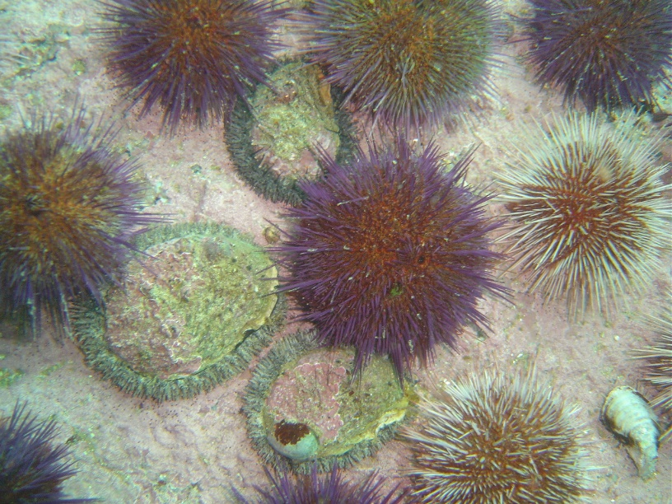

Figure : Image of juvenile abalone (*Haliotis midae*) sheltering beneath Cape sea urchins (*Parechinus angulosus*) in Simon’s Town, Cape Town, South Africa (Peter Southwood, 2005).

## Research aim and objectives

One of the major factors influencing the marketability of sea urchins is their gonad colour and texture (Shpigel et al., 2005). The effects of different temperatures and feeding regimes on the growth performance, optimal gonad colour and gonadal somatic index (GSI) of this species has not been assessed, this project aims to address these knowledge gaps. The spinal colour variation of the Cape sea urchin may potentially impact their gonad colour and thus, may add commercial interest to the species.

* + 1. **Research Aim**

The aim of the study is to assess the potential of the Cape sea urchin, *Parechinus angulosus*, as an additional value-added product within an IMTA system.

* + 1. **Research Objectives:**
       1. Assess somatic growth and gonad development of the Cape sea urchin held at different temperatures: ambient and 17°C.
       2. Assess the effects of different diets on somatic growth and gonad development of the Cape sea urchin: *Ulva lacinulata* (U), *Ecklonia maxima* kelp (K), 16U formulated feed (F), and a combination of the forementioned diets (U, K, F) rotated on a weekly basis to form a mixed diet (M).
       3. Evaluate gonad quality (colour, texture, firmness), under the above-mentioned temperatures and feeding regimes, to assess the feasibility of gonad enhancement and marketability of the Cape sea urchin.
       4. Assess feed conversion ratio, under the above-mentioned temperatures and feeding regimes, of the Cape sea urchin.

# **Literature review**

Parachinus angulosus

* What is it? Where does it live? What does it eat?
* Does it have value (environmental, social, economic, cultural)? What’s it’s role in the food web?
* How does it’s value compare to other urchin species?
* Does this project relate to any gaps in our knowledge about the species?

Echinoculture

* Sea urchin market analysis/summary
* Areas of controversy or need for improvement
* Does this project relate to any gaps within the industry?

Expectations/Previous work

* Has anyone done anything similar? What did they find?
* What are factors that have affected gonad quality/growth rate/feeding rate for other species?

This project

* Motivation for the factors I am considering & methodology followed:
  + Feeds chosen: is it what they naturally eat? (e.g., *Ecklonia maxima* characterizes the environments usually populated by *P. angulosus*)
  + Temperatures chosen
  + How does my methodology compare with other studies
* My expectations from the project?

# **Materials and methods**

## Ethics statement

Wild individuals of *Parechinus angulosus* were collected in Sea Point, Cape Town. This site is not privately owned or protected in any way, according to South African legislation (SAFLII, 2019). This study did not include endangered or protected species. All experimental procedures on animals were in compliance with the welfare guidelines of the DEFF. Daily biosecurity checks were performed for the duration of the study.

## Sea urchin collection

The sea urchins (*Parechinus angulosus*) were collected from the rock pools in front of the Marine Research Aquarium in Sea Point in May 2023. 650 individuals of an average size of 4cm diameter were collected and immediately transported to plastic tanks with recirculating sea water at the Marine Research Aquarium. Prior to the start of the experiment the urchins were weaned off their natural diets for three weeks. Thereafter, the urchins were stocked into oyster mesh baskets (L x W x D: 40 x 29 x 16 cm; mesh size: 6 mm) suspended in smaller plastic tanks (L x W x H: 42 x 36 x 30 cm) at 19 animals per basket and fed *Ecklonia maxima* for two weeks while they acclimatised to the experimental system. A range of sizes were selected for each basket to mitigate against growth rate differences for different size animals. *Parechinus angulosus* has a wide range of test colours (pink, light purple, dark purple, orange and red), some more rare than others. Where possible, equal ratios of urchins with different test colours were selected for each basket.

## Experimental setup

A continuous open flow-through (how many l per hour?) system was set, consisting of 32 rectangular plastic tanks (four tanks for each treatment; chamber size 42 x 36 x 30 cm with 40 l of sea water). Sea water was pumped into the system differently for the two temperature treatments. The ambient temperature treatment tanks received sea water which was pumped from the sea, collected in an indoor basin, then filtered … The heated temperature treatment tanks…

Temperatures for each treatment were continuously recorded at 30 minute intervals using a (apparatus name?)

The aeration in the tanks was provided by airstones. Used water was released through outflow tubes…

The internal surfaces of tanks were manually cleaned of their sediments and fouling organisms twice a week, using a siphon and synthetic fibre brush.

Four feeding regimes will be tested in quadruplicate: *Ulva* (U), kelp (K), a formulated feed containing 20% *Ulva* (F), as well as a combination of the forementioned diets (U, K, F) rotated on a weekly basis to form a mixed diet (M), resulting in a total of 16 tanks (320 sea urchins). All feeds will be administered ad libitum, to avoid overfeeding, the amount of feed added at the start of the experiment was calculated as a percentage of the total body weight within each tank (U: 8%, F: 1.8%, K: 10%).

These feeding regimes will be duplicated across two temperatures: ambient (A: ambient) incoming water (temperature will be continuously recorded) and a consistent temperature (W: warm) of 17°C (temperature controlled using a heat pump). Therefore, a total of 32 tanks will be stocked with sea urchins, equating to 640 sea urchins for inclusion in the study.

The 8 treatments were randomly assigned to tanks in the following arrangement:

Table 1. Tank treatment allocation

(F: formulated feed, M: mixed diet, U: ulva, K: kelp, A: ambient, W: warm).

|  |  |  |  |
| --- | --- | --- | --- |
| FW 1 | MW 2 | FA 3 | MA 4 |
| MW 5 | UW 6 | KA 7 | UA 8 |
| UW 9 | KW 10 | KA 11 | FA 12 |
| FW 13 | MW 14 | UA 15 | MA 16 |
| UW 17 | KW 18 | FA 19 | KA 20 |
| KW 21 | UW 22 | MA 23 | FA 24 |
| MW 25 | FW 26 | UA 27 | UA 28 |
| KW 29 | FW 30 | MA 31 | KA 32 |

## Data collection

### *Somatic growth and feed conversion ratio*

Somatic growth was measured in terms of urchin weight (g) and diameter (cm) at six measurement timepoints (T0: initial, T1: 4 weeks, T2: 8 weeks, T3: 13 weeks, T4: 18 weeks, T5: 23 weeks). At every timepoint all sea urchins were individually weighed and measured using standardised photographs taken with an iPhone 8. All images were processed using the “Urchin Vision” software (De Vos et al., 2023) and diameters were recorded.

Feed conversion ratios were measured for each tank by determining feed consumption over 7 days divided by the corresponding wet weight increase over the 7 days:

$$FCR=\frac{Feed consumed}{Urchin wet weight gain}$$

All urchins were weighed at the start of the week, these values were used for the somatic growth data. All urchins were measured again at the end of the week, these values were used to calculate wet weight increase over the 7 days. The total feed consumed per tank over the 7 days was calculated as the difference between the feed introduced and the residual feed removed from the tank. The amount of feed added to the tank was weighed, in grams, at the start of the week.

Macroalgae tissues (*Ulva* and *Ecklonia maxima*) were still intact after 7 days when residuals were removed and therefore, no significant process of degradation and weight reduction within the experimental time was considered, these tissues were spun using a salad spinner to remove excess moisture before they were weighed. The formulated feed however, was significantly degraded, the residual formulated feed for each tank was thus removed every 3 days and new formulated feed was weighed (g) and added for the experiment. The residual formulated feed was placed into foil weigh boats and dried to a standard weight in an oven at 60oC for 48 hours to remove excess moisture before being weighed. Feed consumption was calculated in milligrams of feed (dry weight) consumed per tank, per week. The feed consumption was then divided by the number of animals in the tank and by the number of days for the feed consumption experiment to calculate the average feed (dry weight in milligrams) consumed per animal, per day. To allow the sea urchins to adapt to the treatments before feed consumption was measured, feed consumption measurements were recorded from T2 onwards.

### *Gonad quality and development*

Gonad quality was measured in terms of GSI (%) and gonad colour approximately every two months (T0GSI: 9 weeks, T1GSI: 19 weeks, T2GSI: 26 weeks). One urchin from each tank was weighed, sacrificed, and dissected; their gonads were carefully removed from the test and all other visceral tissues attached to the gonad were cleaned off, the gonad tissues were weighed (g) for the evaluation of GSI such that:

$$GSI (\%) = \frac{gonad wet weight (g)}{whole sea urchin wet weight (g)}* 100$$

Gonad colour was measured using a hand-held fibre-optic spectrophotometer (Lovibond® LC 100 spectrocolorimeter). For the spectrophotometer rated gonad colour, three replicate measurements of L* (intensity or lightness), a* (hue or redness) and b* (chroma or yellowness) were taken from each sampled gonad (Onomu et al., 2020).

Gonad development was measured by the gametogenic state of the urchin. A single gonad per animal, of the five extracted for the GSI measurements, was fixed in Davidson's fixative to ascertain the gametogenic state of the urchin. After 48 hr of immersion in the fixative, the samples were transferred to 70% ethanol for storage before paraffin histology (Bucke, 1989). Gonad maturity was analysed according to the method described by Cyrus, Bolton, and Macey (2015). Gonads were categorized into one of 6 different maturity stages of echinoid gametogenesis, namely (a) recovery, (b) growing, (c) premature, (d) mature, (e) partly spawned, and (f) spent (Vaïtilingon, Rasolofonirina, & Jangoux, 2005). Gonads having little or no gametogenic activity were considered as high-quality, that is gonads in the growing or premature stages (Onomu et al., 2020).

## Statistical Analyses

To determine whether urchin SGR (in terms of weight and size), mortality, GSI and gonad colour (L*, a* and b*) changed as a function of time within individual treatment groups or as a function of treatment at individual sampling dates, a one-way analysis of variance (ANOVA) was performed using R statistical software (R Core Team, 2023).

The somatic growth data collected in terms of weight (g) (Table no) and size (cm diameter) (Table no) was averaged per tank and used to calculate the specific growth rate (SGR). SGR (% growth/day) (Table no) of each treatment was calculated for five intervals (between each respective timepoint) using mean weight (g) and size (mm) measurements per timepoint per tank per treatment:

$$SGR=100*\frac{(ln⁡(\frac{l_{f}}{l_{i}}))}{t} CITATION Mul13 \backslash l 1033 (Mulvaney, et al., 2013)$$

Where mf = measurement final (g or cm); mi = measurement initial (g or cm); t = time (days) between final and initial measurements.

The intervals for the five specific growth rates calculated:

1. A: week 0 - week 4 (t = 29 days)
2. B: week 4 – week 8 (t = 29 days)
3. C: week 8 – week 13 (t = 32 days)
4. D: week 13 – week 18 (t = 36 days)
5. E: week 18 – week 23 (t = 36 days)

Normality & Homoscedasticity

Normality was assessed using the Shapiro-Wilk test (Shapiro & Wilk, 1965). Homoscedasticity was assessed using a Levene’s test (Schultz, 1985) in the “car” package (Fox & Weisberg, 2019) to compare the variances of the treatment groups.

*Weight*

First, I did Shapiro-Wilk tests on the SGR of all tanks for a given time interval e.g., Shapiro-wilk(tank_SGR_data$SGR1): SGR A, B and D were normal (p = 0.69, p = 0.07, p = 0.35). SGR C was not normal (p = 0.02).

Levene test compares SGR by treatment. (If values are significant, the treatment group data does not have equal variances). SGR A (df = 7 , F= 1.127 p = 0.3792) and D (df = 7, F = 1.7097, p = 0.1542) have equal variances. SGR B (p = 0.03) and C (p = 0.004) do not have equal variances.

* Normal: A,B,D
* Equal variance: A,D
* ANOVA: A,D – results below
* Correct unequal variances: B,C?
* Kruskal Wallis for C?

*Size*

* Only SGR B is normal
* Variances all equal
* So Kruskal Wallis for all except SGR B? – results below

*\*I haven’t managed to get through the analysis for these yet, want to first make sure I’m on the right track with somatic growth*

*Survival rate*

*Feeding rate*

*FCR*

*GSI*

*Gonad colour*

# **Results**

## Survival

*First, I want to plot survival rate to motivate why kelp treatment was cancelled

## Somatic growth

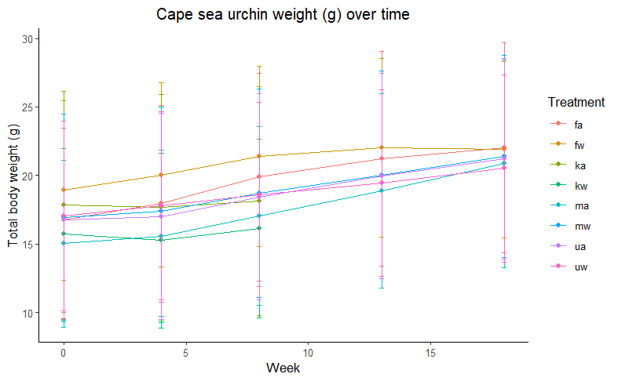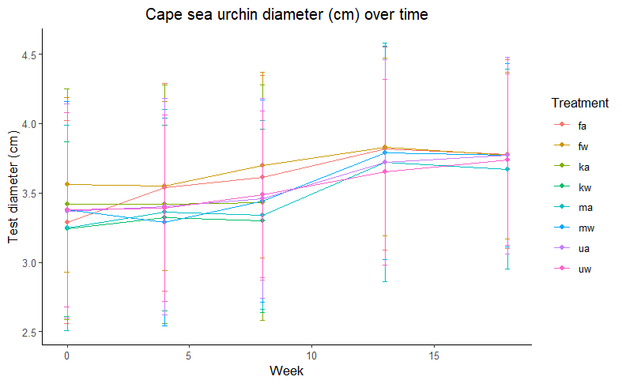

Figure 4: Cape sea urchin mean weight (g) and size in terms of diameter (cm) with standard deviation as error bars over time for the 8 different treatments (f: formulated, m: mixed, u: ulva, k: kelp, w: warm tanks, a: ambient tanks)

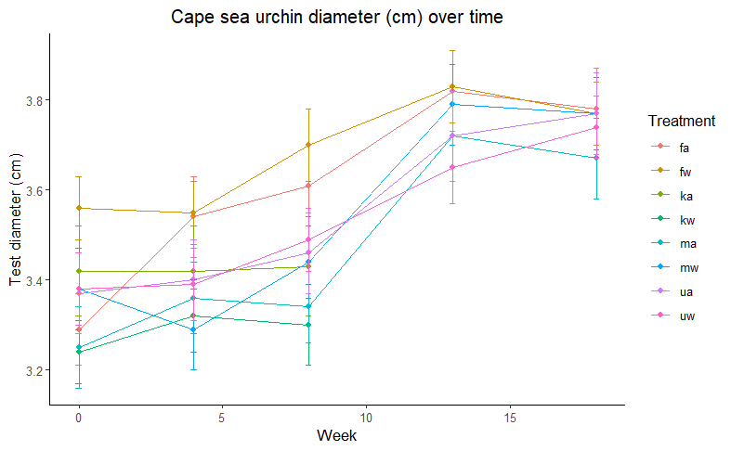

With standard error

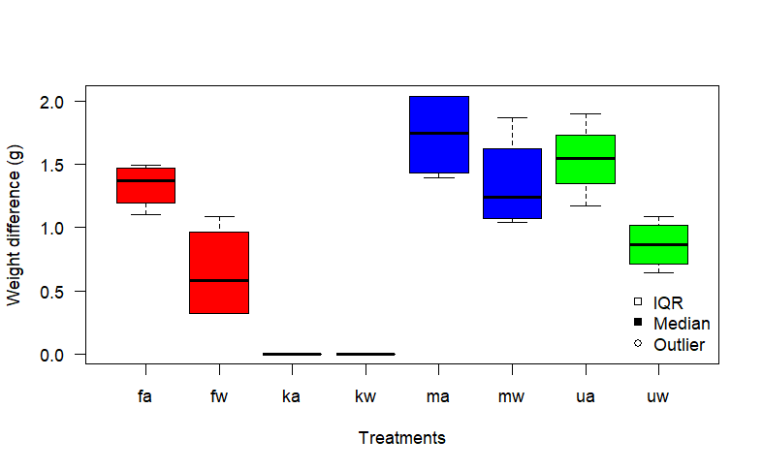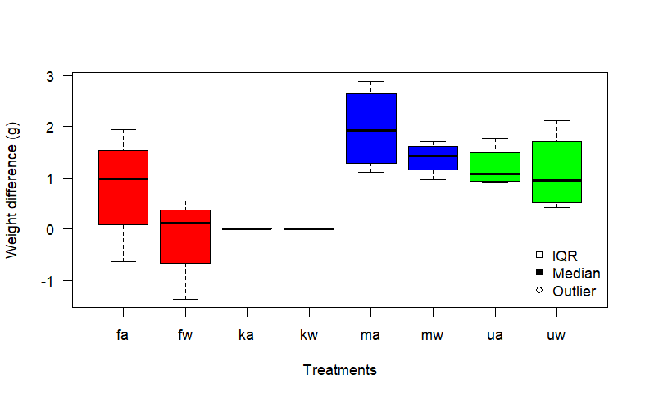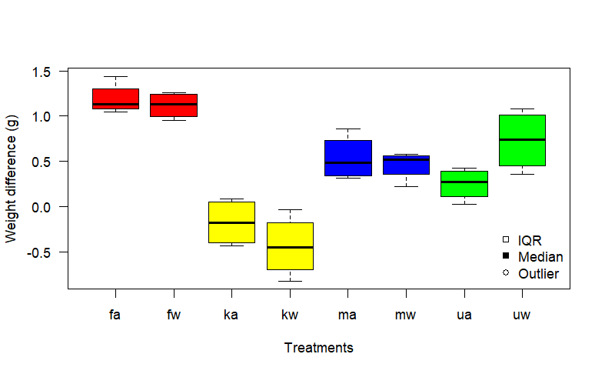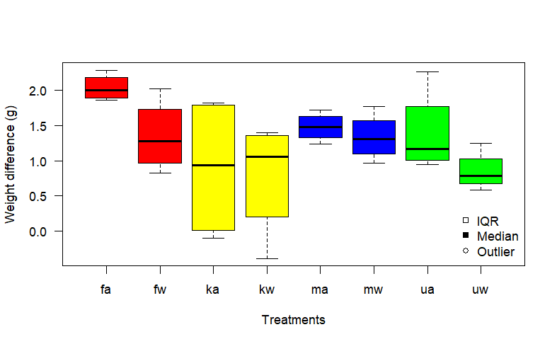

**a**

**b**

**c**

**d**

Figure : Boxplots of somatic growth in terms of weight (g) difference between measurement intervals.

a) T0 and T1 b) T1 and T2 c) T2 and T3 and d) T3 and T4

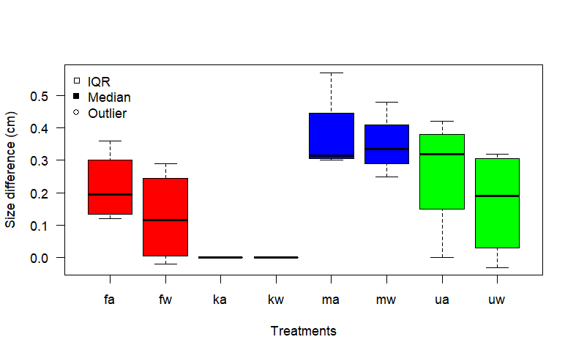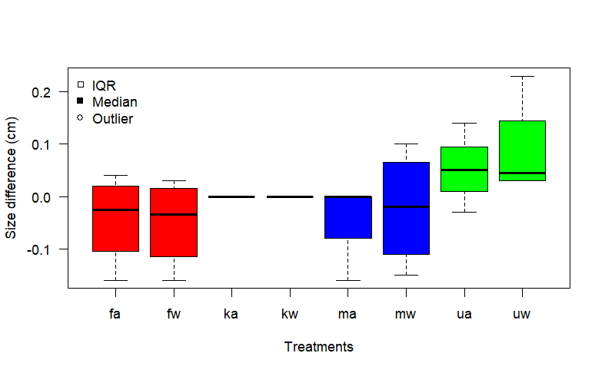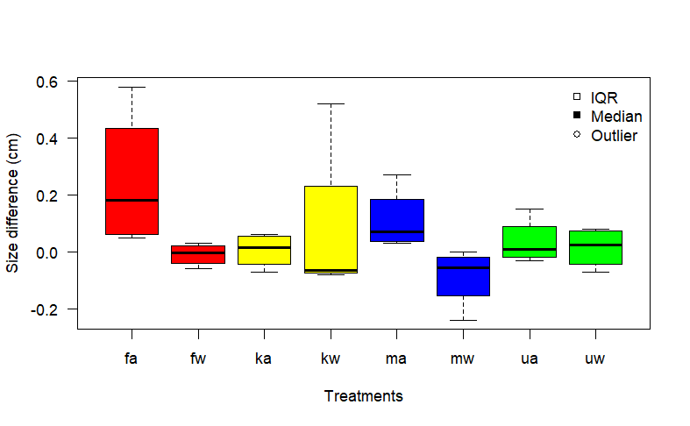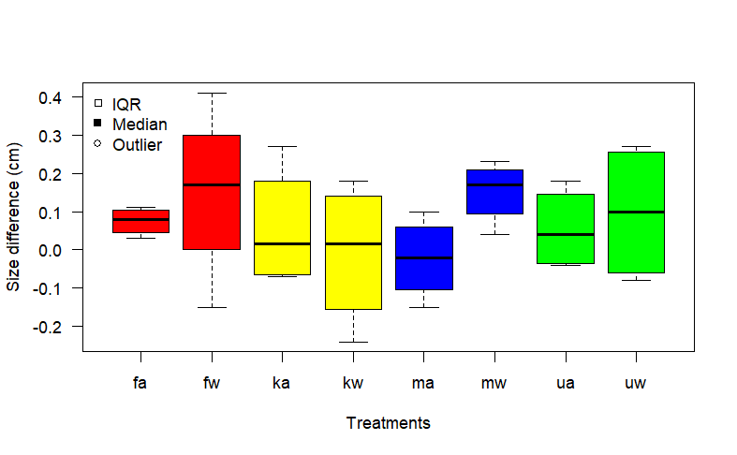

**a**

**b**

**c**

**d**

Figure : Boxplots of somatic growth in terms of size (cm) difference between measurement intervals.

a) T0 and T1 b) T1 and T2 c) T2 and T3 and d) T3 and T4

# **Discussion**

# **Conclusion**

# **References**

Britz P. J., Hecht T., Mangold S., 1997 Effect of temperature on growth, feed consumption and nutritional indices of *Haliotis midae* fed a formulated diet. Aquaculture 152: 191–203.

Britz P.,Venter S., 2016. Aquaculture Review: South Africa. World Aquaculture: 20-28.

Bucke D., 1989. Histology. In B. Austin & D. A. Austin (Eds.), Methods for the microbiological examination of fish and shellfish (pp. 69–97). Chichester: Ellis Horwood.

Day E., Branch G. M., 2000 Relationships between recruits of abalone *Haliotis midae*, encrusting corallines and the sea urchin *Parechinus angulosus*. South African Journal of Marine Science: 137–144.

Day E., Branch G. M., 2002a Influences of the sea urchin *Parechinus angulosus* (Leske) on the feeding behaviour and activity rhythms of juveniles of the South African abalone *Haliotis midae* Linn. Journal of Experimental Marine Biology and Ecology 276: 1–17.

Day E., Branch G. M., 2002b. Effects of sea urchins (*Parechinus angulosus*) on recruits and juveniles of abalone (*Haliotis midae*). Ecological Monographs 72: 133–149.

De Vos B. C., Cyrus M. D., Macey B. M., Batik T., Bolton J. J., 2023. Combining computer vision and standardised protocols for improved measurement of live sea urchins for research and industry. Aquaculture, Fish and Fisheries. <https://doi.org/10.1002/aff2.137>

FAO, 2022. The State of World Fisheries and Aquaculture 2022. Towards Blue Transformation. Rome, FAO. <https://doi.org/10.4060/cc0461en>

Fox J., Weisberg S. 2019. An R Companion to Applied Regression. Third edition. Sage, Thousand Oaks CA. <https://socialsciences.mcmaster.ca/jfox/Books/Companion/>

Fricke A. H., 1980. Aspects of Population Structure of *Parechinus Angulosus* (Leske), Around the Cape Peninsula. South African Journal of Zoology 15: 177–185.

Granada L., Sousa N., Lopes S., Lemos M. F. L., 2016 Is integrated multitrophic aquaculture the solution to the sectors’ major challenges? – a review. Reviews in Aquaculture 8: 283–300.

Kang K. H., Kwon J. Y., Kim Y. M., 2003 A beneficial co-culture : charm abalone *Haliotis discus hannai* and sea cucumber *Stichopus japonicus*. Aquaculture 216: 87–93.

Kim T., Yoon H.S., Shin S., Oh M.H., Kwon I., Lee J., Choi S. D., Jeong K. S., 2015 Physical and biological evaluation of co-culture cage systems for grow-out of juvenile abalone, *Haliotis discus hannai*, with juvenile sea cucumber, *Apostichopus japonicus* (Selenka), with CFD analysis and indoor seawater tanks. Aquaculture 447: 86–101.

Mayfield S., Branch G. M., Cockcroft A. C., 2000. Relationships among diet, growth rate, and food availability for the South African rock lobster, *Jasus lalandii* (Decapoda, Palinuridea). Crustaceana, pp.815-834.

Nepgen C. S., 1982. Diet of predatory and reef fish in False Bay and possible effects of pelagic purse-seining on their food supply. Fisheries bulletin: Contributions to oceanography and fisheries biology-Republic of South Africa, Dept. of Agriculture and Fisheries.

Onomu A. J., Vine N. G., Cyrus M. D., Macey B. M., Bolton J. J., 2020. The effect of fresh seaweed and a formulated diet supplemented with seaweed on the growth and gonad quality of the collector sea urchin *Tripneustes gratilla*, under farm conditions, Aquaculture Research, 51(10): 4087–4102. <https://doi.org/10.1111/are.14752>

R Core Team. 2023. R: A Language and Environment for Statistical Computing. R Foundation for Statistical Computing, Vienna, Austria. <https://www.R-project.org/> .

South African Legal Information Institute (SAFLII). 2019. South Africa: Consolidated Regulations - Declaration of Areas as Marine Protected Areas. Available at: <https://www.saflii.org/za/legis/consol_reg/doaampa357/> (Accessed: 16 November 2023).

Shpigel, M., McBride, S. C., Marciano, S., Ron, S. and Ben-Amotz, A., 2005. Improving gonad colour and somatic index in the European sea urchin *Paracentrotus lividus*. Aquaculture, 245(1-4), pp.101-109.

Smith, C. D., 1999. Population biology and ecology of octopuses in the Southwestern Cape: a study towards the establishment of a small-scale octopus fishery (Master's thesis, University of Cape Town).

# **Appendix**

# Actual Values

Table 100.1. Descriptive statistics for weight (g) of all tanks, in terms of mean, standard deviation and variance, of *P. angulosus* urchins at the start of the experiment.

|  |  |  |  |  |  |  |
| --- | --- | --- | --- | --- | --- | --- |
| Tank | Diet | Temperature | Mean (g) | St. dev (g) | Var (g^2) | n |
| 1 | formulated | warm | 17.62 | 7.1 | 50.3714 | 19 |
| 2 | mixed | warm | 19.28 | 6.46 | 41.764 | 19 |
| 3 | formulated | ambient | 19.32 | 7.23 | 52.2206 | 19 |
| 4 | mixed | ambient | 14.68 | 6 | 35.9936 | 19 |
| 5 | mixed | warm | 17.06 | 6.78 | 45.9281 | 19 |
| 6 | ulva | warm | 17.11 | 5.47 | 29.9299 | 19 |
| 7 | kelp | ambient | 13.89 | 7.97 | 63.5988 | 19 |
| 8 | ulva | ambient | 18.26 | 6.94 | 48.1692 | 19 |
| 9 | ulva | warm | 16.43 | 7.82 | 61.1243 | 19 |
| 10 | kelp | warm | 14.72 | 5.69 | 32.3618 | 19 |
| 11 | kelp | ambient | 18.29 | 6.91 | 47.7743 | 19 |
| 12 | formulated | ambient | 14.97 | 6.4 | 40.942 | 19 |
| 13 | formulated | warm | 22.19 | 6.73 | 45.261 | 19 |
| 14 | mixed | warm | 14.99 | 8.62 | 74.2894 | 19 |
| 15 | ulva | ambient | 13.71 | 8.17 | 66.7072 | 19 |
| 16 | mixed | ambient | 13.64 | 6.63 | 43.9515 | 19 |
| 17 | ulva | warm | 15.85 | 5.82 | 33.8737 | 19 |
| 18 | kelp | warm | 14.75 | 6.88 | 47.3026 | 19 |
| 19 | formulated | ambient | 16.08 | 7.08 | 50.1406 | 19 |
| 20 | kelp | ambient | 19.73 | 9.23 | 85.2745 | 19 |
| 21 | kelp | warm | 17.16 | 5.63 | 31.6559 | 19 |
| 22 | ulva | warm | 18.78 | 8.29 | 68.7347 | 19 |
| 23 | mixed | ambient | 16.76 | 6.5 | 42.2491 | 19 |
| 24 | formulated | ambient | 16.62 | 5.84 | 34.0618 | 19 |
| 25 | mixed | warm | 16.28 | 8.16 | 66.5295 | 19 |
| 26 | formulated | warm | 17.44 | 5.79 | 33.4891 | 19 |
| 27 | ulva | ambient | 17.21 | 5.18 | 26.8821 | 19 |
| 28 | ulva | ambient | 17.83 | 7.92 | 62.7489 | 19 |
| 29 | kelp | warm | 16.18 | 6.89 | 47.5251 | 19 |
| 30 | formulated | warm | 18.45 | 5.87 | 34.5115 | 19 |
| 31 | mixed | ambient | 14.94 | 5.2 | 27.0348 | 19 |
| 32 | kelp | ambient | 19.39 | 8.27 | 68.4083 | 19 |

Table 100.1. Descriptive statistics for weight (g) of all tanks, in terms of mean, standard deviation and variance, of *P. angulosus* urchins at the after 4 weeks.

|  |  |  |  |  |  |  |
| --- | --- | --- | --- | --- | --- | --- |
| Tank | Diet | Temperature | Mean (g) | St. dev (g) | Var (g^2) | n |
| 1 | formulated | warm | 18.88 | 7.26 | 52.6949 | 19 |
| 2 | mixed | warm | 19.5 | 6.96 | 48.4683 | 19 |
| 3 | formulated | ambient | 20.43 | 7.5 | 56.3237 | 19 |
| 4 | mixed | ambient | 15.05 | 5.92 | 35.0205 | 19 |
| 5 | mixed | warm | 17.64 | 6.53 | 42.6362 | 19 |
| 6 | ulva | warm | 18.05 | 5.63 | 31.7518 | 19 |
| 7 | kelp | ambient | 13.98 | 8.12 | 65.911 | 19 |
| 8 | ulva | ambient | 18.62 | 6.96 | 48.4766 | 19 |
| 9 | ulva | warm | 16.79 | 7.98 | 63.7253 | 19 |
| 10 | kelp | warm | 14.15 | 5.54 | 30.7244 | 19 |
| 11 | kelp | ambient | 17.86 | 7.08 | 50.1473 | 19 |
| 12 | formulated | ambient | 16.41 | 7.1 | 50.4783 | 19 |
| 13 | formulated | warm | 23.14 | 6.72 | 45.1203 | 19 |
| 14 | mixed | warm | 15.48 | 8.61 | 74.198 | 19 |
| 15 | ulva | ambient | 13.9 | 8.31 | 69.116 | 19 |
| 16 | mixed | ambient | 14.25 | 6.93 | 48.0077 | 19 |
| 17 | ulva | warm | 16.39 | 5.8 | 33.6618 | 19 |
| 18 | kelp | warm | 13.93 | 6.96 | 48.4531 | 20 |
| 19 | formulated | ambient | 17.24 | 7.83 | 61.3526 | 19 |
| 20 | kelp | ambient | 19.75 | 8.99 | 80.7613 | 19 |
| 21 | kelp | warm | 17.13 | 5.71 | 32.6232 | 19 |
| 22 | ulva | warm | 19.86 | 7.76 | 60.258 | 19 |
| 23 | mixed | ambient | 17.08 | 6.89 | 47.4139 | 19 |
| 24 | formulated | ambient | 17.67 | 6.16 | 37.928 | 19 |
| 25 | mixed | warm | 16.83 | 8.27 | 68.32 | 19 |
| 26 | formulated | warm | 18.66 | 6.01 | 36.1585 | 19 |
| 27 | ulva | ambient | 17.24 | 6.33 | 40.0348 | 19 |
| 28 | ulva | ambient | 18.26 | 8.04 | 64.5841 | 19 |
| 29 | kelp | warm | 15.85 | 7.04 | 49.5105 | 19 |
| 30 | formulated | warm | 19.49 | 6.28 | 39.4706 | 19 |
| 31 | mixed | ambient | 15.8 | 5.51 | 30.398 | 19 |
| 32 | kelp | ambient | 19.02 | 8.21 | 67.4632 | 19 |

Table 100.1. Descriptive statistics for weight (g) of all tanks, in terms of mean, standard deviation and variance, of *P. angulosus* urchins at the after 8 weeks.

|  |  |  |  |  |  |  |
| --- | --- | --- | --- | --- | --- | --- |
| Tank | Diet | Temperature | Mean (g) | St. dev (g) | Var (g^2) | n |
| 1 | formulated | warm | 19.99 | 7.41 | 54.867 | 19 |
| 2 | mixed | warm | 20.47 | 6.89 | 47.4198 | 19 |
| 3 | formulated | ambient | 22.72 | 8.32 | 69.2303 | 16 |
| 4 | mixed | ambient | 16.59 | 6.01 | 36.1658 | 19 |
| 5 | mixed | warm | 18.87 | 6.23 | 38.8186 | 19 |
| 6 | ulva | warm | 19.3 | 5.38 | 28.9925 | 19 |
| 7 | kelp | ambient | 13.88 | 8.18 | 66.8324 | 19 |
| 8 | ulva | ambient | 19.68 | 7.56 | 57.108 | 16 |
| 9 | ulva | warm | 17.37 | 7.87 | 61.9862 | 19 |
| 10 | kelp | warm | 14.94 | 5.36 | 28.6934 | 12 |
| 11 | kelp | ambient | 17.97 | 7.99 | 63.7908 | 12 |
| 12 | formulated | ambient | 18.27 | 7.11 | 50.615 | 19 |
| 13 | formulated | warm | 23.97 | 6.55 | 42.952 | 19 |
| 14 | mixed | warm | 16.86 | 8.62 | 74.3562 | 19 |
| 15 | ulva | ambient | 15.18 | 8.18 | 66.9169 | 16 |
| 16 | mixed | ambient | 15.97 | 7.14 | 51.034 | 17 |
| 17 | ulva | warm | 17.15 | 5.56 | 30.9516 | 19 |
| 18 | kelp | warm | 15.25 | 7.71 | 59.4627 | 15 |
| 19 | formulated | ambient | 19.17 | 8.13 | 66.1694 | 18 |
| 20 | kelp | ambient | 21.57 | 8.6 | 73.9394 | 14 |
| 21 | kelp | warm | 16.74 | 5.79 | 33.4755 | 19 |
| 22 | ulva | warm | 20.67 | 7.63 | 58.2224 | 18 |
| 23 | mixed | ambient | 18.5 | 7.34 | 53.8874 | 19 |
| 24 | formulated | ambient | 19.75 | 6.7 | 44.8302 | 17 |
| 25 | mixed | warm | 18.6 | 8.52 | 72.6662 | 19 |
| 26 | formulated | warm | 20.1 | 6.08 | 36.9106 | 19 |
| 27 | ulva | ambient | 19.51 | 5.45 | 29.7481 | 16 |
| 28 | ulva | ambient | 19.21 | 8.21 | 67.4352 | 19 |
| 29 | kelp | warm | 17.25 | 7.4 | 54.8009 | 13 |
| 30 | formulated | warm | 21.51 | 5.87 | 34.4628 | 18 |
| 31 | mixed | ambient | 17.04 | 5.8 | 33.5914 | 19 |
| 32 | kelp | ambient | 20.79 | 6.49 | 42.1843 | 13 |

Table 100.1. Descriptive statistics for weight (g) of all tanks, in terms of mean, standard deviation and variance, of *P. angulosus* urchins at the after 13 weeks.

|  |  |  |  |  |  |  |
| --- | --- | --- | --- | --- | --- | --- |
| Tank | Diet | Temperature | Mean (g) | St. dev (g) | Var (g^2) | n |
| 1 | formulated | warm | 20.31 | 7.27 | 52.9097 | 18 |
| 2 | mixed | warm | 21.58 | 6.96 | 48.4486 | 17 |
| 3 | formulated | ambient | 24.17 | 8.44 | 71.2403 | 15 |
| 4 | mixed | ambient | 18.63 | 6.13 | 37.5615 | 18 |
| 5 | mixed | warm | 20.74 | 6.27 | 39.3043 | 18 |
| 6 | ulva | warm | 20.25 | 5.78 | 33.3526 | 17 |
| 8 | ulva | ambient | 21.21 | 7.65 | 58.5474 | 14 |
| 9 | ulva | warm | 18.46 | 7.79 | 60.7417 | 19 |
| 12 | formulated | ambient | 19.56 | 7.34 | 53.9176 | 18 |
| 13 | formulated | warm | 24.29 | 6.43 | 41.294 | 18 |
| 14 | mixed | warm | 17.9 | 8.29 | 68.7212 | 18 |
| 15 | ulva | ambient | 16.74 | 8.14 | 66.1864 | 14 |
| 16 | mixed | ambient | 17.36 | 8.09 | 65.4172 | 13 |
| 17 | ulva | warm | 17.93 | 5.47 | 29.9158 | 18 |
| 19 | formulated | ambient | 20.66 | 8.6 | 73.9368 | 16 |
| 22 | ulva | warm | 21.31 | 7.76 | 60.2145 | 17 |
| 23 | mixed | ambient | 20.53 | 8.22 | 67.5477 | 18 |
| 24 | formulated | ambient | 20.85 | 6.96 | 48.4965 | 15 |
| 25 | mixed | warm | 19.97 | 8.66 | 74.9715 | 18 |
| 26 | formulated | warm | 20.94 | 6.09 | 37.0816 | 18 |
| 27 | ulva | ambient | 21.41 | 5.01 | 25.057 | 13 |
| 28 | ulva | ambient | 20.38 | 8.14 | 66.33 | 19 |
| 30 | formulated | warm | 22.6 | 5.99 | 35.8858 | 17 |
| 31 | mixed | ambient | 18.51 | 6.18 | 38.24 | 18 |

Table 100.1. Descriptive statistics for weight (g) of all tanks, in terms of mean, standard deviation and variance, of *P. angulosus* urchins at the after 18 weeks.

|  |  |  |  |  |  |  |
| --- | --- | --- | --- | --- | --- | --- |
| Tank | Diet | Temperature | Mean (g) | St. dev (g) | Var (g^2) | n |
| 1 | formulated | warm | 20.86 | 7.17 | 51.3513 | 18 |
| 2 | mixed | warm | 22.55 | 6.89 | 47.4575 | 16 |
| 3 | formulated | ambient | 23.53 | 8.24 | 67.8439 | 15 |
| 4 | mixed | ambient | 21.52 | 7.5 | 56.2624 | 18 |
| 5 | mixed | warm | 22.25 | 5.98 | 35.7588 | 18 |
| 6 | ulva | warm | 22.37 | 6.82 | 46.5223 | 17 |
| 8 | ulva | ambient | 22.42 | 7.84 | 61.4795 | 13 |
| 9 | ulva | warm | 19.07 | 7.61 | 57.8832 | 19 |
| 12 | formulated | ambient | 20.38 | 7.11 | 50.5622 | 18 |
| 13 | formulated | warm | 24.49 | 6.32 | 39.9653 | 18 |
| 14 | mixed | warm | 19.62 | 8.2 | 67.1733 | 18 |
| 15 | ulva | ambient | 18.51 | 7.76 | 60.2014 | 12 |
| 16 | mixed | ambient | 18.81 | 8.37 | 70.0828 | 12 |
| 17 | ulva | warm | 19.23 | 5.2 | 27.0423 | 18 |
| 19 | formulated | ambient | 22.6 | 8.48 | 71.8704 | 13 |
| 22 | ulva | warm | 21.73 | 7.43 | 55.1716 | 16 |
| 23 | mixed | ambient | 22.94 | 7.92 | 62.655 | 17 |
| 24 | formulated | ambient | 21.98 | 7.4 | 54.727 | 15 |
| 25 | mixed | warm | 21.31 | 8.42 | 70.9714 | 18 |
| 26 | formulated | warm | 19.57 | 5.89 | 34.7206 | 18 |
| 27 | ulva | ambient | 22.35 | 5.44 | 29.6476 | 13 |
| 28 | ulva | ambient | 21.3 | 8 | 63.9325 | 18 |
| 30 | formulated | warm | 22.64 | 5.74 | 32.9467 | 17 |
| 31 | mixed | ambient | 19.62 | 6.86 | 47.1272 | 18 |

Table 100.1. Descriptive statistics for weight (g) of all tanks, in terms of mean, standard deviation and variance, of *P. angulosus* urchins at the after 23 weeks.

****still to be captured*******

Table 100.1. Descriptive statistics for weight (g), in terms of mean, standard deviation and variance, of *P. angulosus* urchins given the formulated diet and ambient temperature treatment.

|  |  |  |  |  |
| --- | --- | --- | --- | --- |
| Month | Mean (g) | St. dev (g) | Var (g^2) | n |
| 0 | 16.75 | 6.72 | 45.1599 | 76 |
| 1 | 17.94 | 7.19 | 51.7618 | 76 |
| 2 | 19.88 | 7.59 | 57.6719 | 70 |
| 3 | 21.22 | 7.86 | 61.7377 | 64 |
| 4 | 22.02 | 7.66 | 58.7519 | 61 |

Table 100.1. Descriptive statistics for size (cm), in terms of mean, standard deviation and variance, of *P. angulosus* urchins given the formulated diet and ambient temperature treatment.

|  |  |  |  |  |
| --- | --- | --- | --- | --- |
| Month | Mean (cm) | St. dev (cm) | Var (cm^2) | n |
| 0 | 3.29 | 0.73 | 0.5262 | 76 |
| 1 | 3.54 | 0.75 | 0.5594 | 76 |
| 2 | 3.61 | 0.74 | 0.5495 | 70 |
| 3 | 3.82 | 0.73 | 0.5304 | 64 |
| 4 | 3.78 | 0.68 | 0.469 | 61 |
|  |  |  |  |  |

Table 100.2. Descriptive statistics for weight (g), in terms of mean, standard deviation and variance, of *P. angulosus* urchins given the formulated diet and heated temperature treatment.

|  |  |  |  |  |
| --- | --- | --- | --- | --- |
| Month | Mean (g) | St. dev (g) | Var (g^2) | n |
| 0 | 18.92 | 6.56 | 43.0247 | 76 |
| 1 | 20.04 | 6.70 | 44.956 | 76 |
| 2 | 21.39 | 6.58 | 43.3293 | 75 |
| 3 | 22.03 | 6.52 | 42.5377 | 71 |
| 4 | 21.88 | 6.45 | 41.6619 | 71 |
|  |  |  |  |  |

Table 100.2. Descriptive statistics for size (g), in terms of mean, standard deviation and variance, of *P. angulosus* urchins given the formulated diet and heated temperature treatment.

|  |  |  |  |  |
| --- | --- | --- | --- | --- |
| Month | Mean (cm) | St. dev (cm) | Var (cm^2) | n |
| 0 | 3.56 | 0.63 | 0.3996 | 76 |
| 1 | 3.55 | 0.61 | 0.3728 | 76 |
| 2 | 3.7 | 0.67 | 0.4507 | 75 |
| 3 | 3.83 | 0.64 | 0.4074 | 71 |
| 4 | 3.77 | 0.6 | 0.3653 | 71 |

Table 100.3. Descriptive statistics for weight (g), in terms of mean, standard deviation and variance, of *P. angulosus* urchins given the mixed diet and ambient temperature treatment.

|  |  |  |  |  |
| --- | --- | --- | --- | --- |
| Month | Mean (g) | St. dev (g) | Var (g^2) | n |
| 0 | 15.01 | 6.09 | 37.0957 | 76 |
| 1 | 15.54 | 6.30 | 39.7021 | 76 |
| 2 | 17.05 | 6.52 | 42.5457 | 74 |
| 3 | 18.86 | 7.08 | 50.0708 | 67 |
| 4 | 20.86 | 7.59 | 57.659 | 65 |

Table 100.3. Descriptive statistics for size (cm), in terms of mean, standard deviation and variance, of *P. angulosus* urchins given the mixed diet and ambient temperature treatment.

|  |  |  |  |  |
| --- | --- | --- | --- | --- |
| Month | Mean (cm) | St. dev (cm) | Var (cm^2) | n |
| 0 | 3.25 | 0.74 | 0.5511 | 76 |
| 1 | 3.36 | 0.74 | 0.5421 | 76 |
| 2 | 3.34 | 0.68 | 0.4585 | 74 |
| 3 | 3.72 | 0.86 | 0.7352 | 67 |
| 4 | 3.67 | 0.72 | 0.5237 | 65 |
|  |  |  |  |  |

Table 100.4. Descriptive statistics for weight (g), in terms of mean, standard deviation and variance, of *P. angulosus* urchins given the mixed diet and heated temperature treatment.

|  |  |  |  |  |
| --- | --- | --- | --- | --- |
| Month | Mean (g) | St. dev (g) | Var (g^2) | n |
| 0 | 16.9 | 7.57 | 57.3 | 76 |
| 1 | 17.36 | 7.63 | 58.2207 | 76 |
| 2 | 18.7 | 7.59 | 57.6426 | 76 |
| 3 | 20.03 | 7.58 | 57.3896 | 71 |
| 4 | 21.4 | 7.38 | 54.4874 | 70 |

Table 100.4. Descriptive statistics for size (cm), in terms of mean, standard deviation and variance, of *P. angulosus* urchins given the mixed diet and heated temperature treatment.

|  |  |  |  |  |
| --- | --- | --- | --- | --- |
| Month | Mean (cm) | St. dev (cm) | Var (cm^2) | n |
| 0 | 3.38 | 0.78 | 0.6124 | 76 |
| 1 | 3.29 | 0.75 | 0.5582 | 76 |
| 2 | 3.44 | 0.73 | 0.5278 | 76 |
| 3 | 3.79 | 0.77 | 0.5891 | 71 |
| 4 | 3.77 | 0.66 | 0.4395 | 71 |
|  |  |  |  |  |

Table 100.5. Descriptive statistics for weight (g), in terms of mean, standard deviation and variance, of *P. angulosus* urchins given the ulva diet and heated temperature treatment.

|  |  |  |  |  |
| --- | --- | --- | --- | --- |
| Month | Mean (g) | St. dev (g) | Var (g^2) | n |
| 0 | 17.04 | 6.91 | 47.7067 | 76 |
| 1 | 17.77 | 6.88 | 47.316 | 76 |
| 2 | 18.59 | 6.72 | 45.1395 | 75 |
| 3 | 19.44 | 6.79 | 46.1328 | 71 |
| 4 | 20.52 | 6.84 | 46.7333 | 70 |

Table 100.5. Descriptive statistics for size (cm), in terms of mean, standard deviation and variance, of *P. angulosus* urchins given the ulva diet and heated temperature treatment.

|  |  |  |  |  |
| --- | --- | --- | --- | --- |
| Month | Mean (cm) | St. dev (cm) | Var (cm^2) | n |
| 0 | 3.38 | 0.7 | 0.4963 | 76 |
| 1 | 3.39 | 0.67 | 0.4552 | 76 |
| 2 | 3.49 | 0.6 | 0.3544 | 75 |
| 3 | 3.65 | 0.67 | 0.4524 | 71 |
| 4 | 3.74 | 0.62 | 0.3857 | 70 |

Table 100.6. Descriptive statistics for weight (g), in terms of mean, standard deviation and variance, of *P. angulosus* urchins given the ulva diet and ambient temperature treatment.

|  |  |  |  |  |
| --- | --- | --- | --- | --- |
| Month | Mean (g) | St. dev (g) | Var (g^2) | n |
| 0 | 16.75 | 7.24 | 52.3564 | 76 |
| 1 | 17.01 | 7.54 | 56.8468 | 76 |
| 2 | 18.43 | 7.53 | 56.7291 | 67 |
| 3 | 19.95 | 7.49 | 56.1659 | 60 |
| 4 | 21.21 | 7.34 | 53.9317 | 56 |

Table 100.6. Descriptive statistics for size (cm), in terms of mean, standard deviation and variance, of *P. angulosus* urchins given the ulva diet and ambient temperature treatment.

|  |  |  |  |  |
| --- | --- | --- | --- | --- |
| Month | Mean (cm) | St. dev (cm) | Var (cm^2) | n |
| 0 | 3.37 | 0.77 | 0.5867 | 76 |
| 1 | 3.4 | 0.78 | 0.6122 | 76 |
| 2 | 3.46 | 0.72 | 0.513 | 67 |
| 3 | 3.72 | 0.74 | 0.5518 | 60 |
| 4 | 3.77 | 0.71 | 0.5068 | 58 |

Table 100.8. Descriptive statistics for weight (g), in terms of mean, standard deviation and variance, of *P. angulosus* urchins given the kelp diet and heated temperature treatment.

|  |  |  |  |  |
| --- | --- | --- | --- | --- |
| Month | Mean (g) | St. dev (g) | Var (g^2) | n |
| 0 | 15.7 | 6.26 | 39.1921 | 76 |
| 1 | 15.25 | 6.37 | 40.5782 | 77 |
| 2 | 16.11 | 6.51 | 42.4152 | 59 |

Table 100.8. Descriptive statistics for size (cm), in terms of mean, standard deviation and variance, of *P. angulosus* urchins given the kelp diet and heated temperature treatment.

|  |  |  |  |  |
| --- | --- | --- | --- | --- |
| Month | Mean (cm) | St. dev (cm) | Var (cm^2) | n |
| 0 | 3.24 | 0.63 | 0.3914 | 76 |
| 1 | 3.32 | 0.67 | 0.4504 | 76 |
| 2 | 3.3 | 0.66 | 0.434 | 59 |

Table 100.7. Descriptive statistics for weight (g), in terms of mean, standard deviation and variance, of *P. angulosus* urchins given the kelp diet and ambient temperature treatment.

|  |  |  |  |  |
| --- | --- | --- | --- | --- |
| Month | Mean (g) | St. dev (g) | Var (g^2) | n |
| 0 | 17.83 | 8.31 | 69.1369 | 76 |
| 1 | 17.65 | 8.27 | 68.436 | 76 |
| 2 | 18.13 | 8.35 | 69.7097 | 58 |

Table 100.7. Descriptive statistics for size (cm), in terms of mean, standard deviation and variance, of *P. angulosus* urchins given the kelp diet and ambient temperature treatment.

|  |  |  |  |  |
| --- | --- | --- | --- | --- |
| Month | Mean (cm) | St. dev (cm) | Var (cm^2) | n |
| 0 | 3.42 | 0.83 | 0.6961 | 76 |
| 1 | 3.42 | 0.86 | 0.7474 | 76 |
| 2 | 3.43 | 0.85 | 0.7188 | 58 |

# Somatic growth rate values

Table 100.8. The difference in weight (g), for *P. angulosus* urchins under different diet and temperature treatments over 4 measurement intervals (T0, T1, T2, T3, T4).

|  |  |  |  |  |  |  |  |
| --- | --- | --- | --- | --- | --- | --- | --- |
| Tank | Diet | Temperature | Weight  (T1-T0) (g) | Weight  (T2-T1) (g) | Weight  (T3-T2) (g) |  | Weight  (T4-T3) (g) |
| 1 | formulated | warm | 1.26 | 1.11 | 0.32 |  | 0.55 |
| 2 | mixed | warm | 0.22 | 0.97 | 1.11 |  | 0.97 |
| 3 | formulated | ambient | 1.11 | 2.29 | 1.45 |  | -0.64 |
| 4 | mixed | ambient | 0.37 | 1.54 | 2.04 |  | 2.89 |
| 5 | mixed | warm | 0.58 | 1.23 | 1.87 |  | 1.51 |
| 6 | ulva | warm | 0.94 | 1.25 | 0.95 |  | 2.12 |
| 7 | kelp | ambient | 0.09 | -0.1 | 0 |  | 0 |
| 8 | ulva | ambient | 0.36 | 1.06 | 1.53 |  | 1.21 |
| 9 | ulva | warm | 0.36 | 0.58 | 1.09 |  | 0.61 |
| 10 | kelp | warm | -0.57 | 0.79 | 0 |  | 0 |
| 11 | kelp | ambient | -0.43 | 0.11 | 0 |  | 0 |
| 12 | formulated | ambient | 1.44 | 1.86 | 1.29 |  | 0.82 |
| 13 | formulated | warm | 0.95 | 0.83 | 0.32 |  | 0.2 |
| 14 | mixed | warm | 0.49 | 1.38 | 1.04 |  | 1.72 |
| 15 | ulva | ambient | 0.19 | 1.28 | 1.56 |  | 1.77 |
| 16 | mixed | ambient | 0.61 | 1.72 | 1.39 |  | 1.45 |
| 17 | ulva | warm | 0.54 | 0.76 | 0.78 |  | 1.3 |
| 18 | kelp | warm | -0.82 | 1.32 | 0 |  | 0 |
| 19 | formulated | ambient | 1.16 | 1.93 | 1.49 |  | 1.94 |
| 20 | kelp | ambient | 0.02 | 1.82 | 0 |  | 0 |
| 21 | kelp | warm | -0.03 | -0.39 | 0 |  | 0 |
| 22 | ulva | warm | 1.08 | 0.81 | 0.64 |  | 0.42 |
| 23 | mixed | ambient | 0.32 | 1.42 | 2.03 |  | 2.41 |
| 24 | formulated | ambient | 1.05 | 2.08 | 1.1 |  | 1.13 |
| 25 | mixed | warm | 0.55 | 1.77 | 1.37 |  | 1.34 |
| 26 | formulated | warm | 1.22 | 1.44 | 0.84 |  | -1.37 |
| 27 | ulva | ambient | 0.03 | 2.27 | 1.9 |  | 0.94 |
| 28 | ulva | ambient | 0.43 | 0.95 | 1.17 |  | 0.92 |
| 29 | kelp | warm | -0.33 | 1.4 | 0 |  | 0 |
| 30 | formulated | warm | 1.04 | 2.02 | 1.09 |  | 0.04 |
| 31 | mixed | ambient | 0.86 | 1.24 | 1.47 |  | 1.11 |
| 32 | kelp | ambient | -0.37 | 1.77 | 0 |  | 0 |

Table 100.8. The difference in size (cm), for *P. angulosus* urchins under different diet and temperature treatments over 4 measurement intervals (T0, T1, T2, T3, T4).

|  |  |  |  |  |  |  |
| --- | --- | --- | --- | --- | --- | --- |
| Tank | Diet | Temperature | Size  (T1-T0) (cm) | Size  (T2-T1) (cm) | Size  (T3-T2) (cm) | Size  (T4-T3) (cm) |
| 1 | formulated | warm | 0.03 | -0.15 | 0.29 | -0.07 |
| 2 | mixed | warm | 0 | 0.04 | 0.25 | 0.03 |
| 3 | formulated | ambient | 0.58 | 0.03 | 0.15 | -0.05 |
| 4 | mixed | ambient | 0.1 | 0.02 | 0.3 | 0 |
| 5 | mixed | warm | -0.24 | 0.23 | 0.33 | 0.1 |
| 6 | ulva | warm | 0.07 | -0.08 | 0.32 | 0.06 |
| 7 | kelp | ambient | -0.02 | -0.07 | 0 | 0 |
| 8 | ulva | ambient | 0.15 | 0.18 | 0 | 0.14 |
| 9 | ulva | warm | -0.07 | 0.27 | -0.03 | 0.23 |
| 10 | kelp | warm | -0.06 | 0.18 | 0 | 0 |
| 11 | kelp | ambient | 0.06 | -0.06 | 0 | 0 |
| 12 | formulated | ambient | 0.29 | 0.1 | 0.12 | 0 |
| 13 | formulated | warm | -0.02 | 0.19 | -0.02 | 0 |
| 14 | mixed | warm | -0.07 | 0.19 | 0.48 | -0.15 |
| 15 | ulva | ambient | 0.03 | 0.11 | 0.3 | 0.05 |
| 16 | mixed | ambient | 0.04 | 0.1 | 0.31 | 0 |
| 17 | ulva | warm | 0.08 | 0.24 | 0.09 | 0.03 |
| 18 | kelp | warm | -0.07 | 0.1 | 0 | 0 |
| 19 | formulated | ambient | 0.05 | 0.11 | 0.24 | 0.04 |
| 20 | kelp | ambient | 0.05 | 0.09 | 0 | 0 |
| 21 | kelp | warm | -0.08 | -0.07 | 0 | 0 |
| 22 | ulva | warm | -0.02 | -0.04 | 0.29 | 0.03 |
| 23 | mixed | ambient | 0.27 | -0.06 | 0.57 | -0.16 |
| 24 | formulated | ambient | 0.07 | 0.06 | 0.36 | -0.16 |
| 25 | mixed | warm | -0.04 | 0.15 | 0.34 | -0.07 |
| 26 | formulated | warm | -0.06 | 0.15 | 0.2 | -0.16 |
| 27 | ulva | ambient | -0.01 | -0.04 | 0.42 | 0.05 |
| 28 | ulva | ambient | -0.03 | -0.03 | 0.34 | -0.03 |
| 29 | kelp | warm | 0.52 | -0.24 | 0 | 0 |
| 30 | formulated | warm | 0.01 | 0.41 | 0.03 | 0.03 |
| 31 | mixed | ambient | 0.03 | -0.15 | 0.32 | 0 |
| 32 | kelp | ambient | -0.07 | 0.27 | 0 | 0 |

Table 100.8. The difference in weight (g), for *P. angulosus* urchins under different diet (Kelp, Ulva, Mixed, Formulated) and temperature (Warm, Ambient) treatments between T0 and T1.

|  |  |  |  |  |
| --- | --- | --- | --- | --- |
| Treatment | Mean (g) | St. dev (g) | Var (g^2) | n |
| KW | -0.438 | 0.337 | 0.113825 | 4 |
| KA | -0.172 | 0.265 | 0.070425 | 4 |
| UA | 0.252 | 0.179 | 0.032158 | 4 |
| MW | 0.46 | 0.164 | 0.027 | 4 |
| MA | 0.54 | 0.248 | 0.061533 | 4 |
| UW | 0.73 | 0.336 | 0.1132 | 4 |
| FW | 1.117 | 0.147 | 0.021625 | 4 |
| FA | 1.19 | 0.173 | 0.0298 | 4 |

Table 100.8. The difference in size (cm), for *P. angulosus* urchins under different diet (Kelp, Ulva, Mixed, Formulated) and temperature (Warm, Ambient) treatments between T0 and T1.

|  |  |  |  |  |
| --- | --- | --- | --- | --- |
| Treatments | Mean (cm) | St. dev (cm) | Var (cm^2) | n |
| MW | -0.088 | 0.106 | 0.011158 | 4 |
| FW | -0.01 | 0.039 | 0.001533 | 4 |
| KA | 0.005 | 0.061 | 0.003767 | 4 |
| UW | 0.015 | 0.072 | 0.005233 | 4 |
| UA | 0.035 | 0.081 | 0.0065 | 4 |
| KW | 0.078 | 0.295 | 0.087092 | 4 |
| MA | 0.11 | 0.111 | 0.012333 | 4 |
| FA | 0.248 | 0.247 | 0.060958 | 4 |

Table 100.8. The difference in weight (g), for *P. angulosus* urchins under different diet (Kelp, Ulva, Mixed, Formulated) and temperature (Warm, Ambient) treatments between T1 and T2.

|  |  |  |  |  |
| --- | --- | --- | --- | --- |
| Treatments | Mean (g) | St. dev (g) | Var (g^2) | n |
| KW | 0.78 | 0.826 | 0.681667 | 4 |
| UW | 0.85 | 0.284 | 0.080867 | 4 |
| KA | 0.9 | 1.037 | 1.0758 | 4 |
| MW | 1.337 | 0.334 | 0.111825 | 4 |
| FW | 1.35 | 0.512 | 0.261667 | 4 |
| UA | 1.39 | 0.602 | 0.363 | 4 |
| MA | 1.48 | 0.202 | 0.0408 | 4 |
| FA | 2.04 | 0.19 | 0.0362 | 4 |

Table 100.8. The difference in size (cm), for *P. angulosus* urchins under different diet (Kelp, Ulva, Mixed, Formulated) and temperature (Warm, Ambient) treatments between T1 and T2.

|  |  |  |  |  |
| --- | --- | --- | --- | --- |
| Treatments | Mean (cm) | St. dev (cm) | Var (cm^2) | n |
| MA | -0.022 | 0.107 | 0.011492 | 4 |
| KW | -0.007 | 0.187 | 0.034892 | 4 |
| UA | 0.055 | 0.108 | 0.011633 | 4 |
| KA | 0.058 | 0.159 | 0.025425 | 4 |
| FA | 0.075 | 0.037 | 0.001367 | 4 |
| UW | 0.098 | 0.183 | 0.033492 | 4 |
| FW | 0.15 | 0.23 | 0.053067 | 4 |
| MW | 0.152 | 0.082 | 0.006692 | 4 |

Table 100.8. The difference in weight (g), for *P. angulosus* urchins under different diet (Kelp, Ulva, Mixed, Formulated) and temperature (Warm, Ambient) treatments between T2 and T3.

|  |  |  |  |  |
| --- | --- | --- | --- | --- |
| Treatments | Mean (g) | St. dev (g) | Var (g^2) | n |
| KA | 0 | 0 | 0 | 4 |
| KW | 0 | 0 | 0 | 4 |
| FW | 0.643 | 0.386 | 0.149092 | 4 |
| UW | 0.865 | 0.196 | 0.038567 | 4 |
| FA | 1.332 | 0.177 | 0.031492 | 4 |
| MW | 1.348 | 0.376 | 0.141492 | 4 |
| UA | 1.54 | 0.298 | 0.089 | 4 |
| MA | 1.732 | 0.351 | 0.123092 | 4 |

Table 100.8. The difference in size (cm), for *P. angulosus* urchins under different diet (Kelp, Ulva, Mixed, Formulated) and temperature (Warm, Ambient) treatments between T2 and T3.

|  |  |  |  |  |
| --- | --- | --- | --- | --- |
| Treatments | Mean (cm) | St. dev (cm) | Var (cm^2) | n |
| KA | 0 | 0 | 0 | 4 |
| KW | 0 | 0 | 0 | 4 |
| FW | 0.125 | 0.145 | 0.020967 | 4 |
| UW | 0.167 | 0.167 | 0.027758 | 4 |
| FA | 0.218 | 0.108 | 0.011625 | 4 |
| UA | 0.265 | 0.184 | 0.0337 | 4 |
| MW | 0.35 | 0.096 | 0.009133 | 4 |
| MA | 0.375 | 0.13 | 0.016967 | 4 |

Table 100.8. The difference in weight (g), for *P. angulosus* urchins under different diet (Kelp, Ulva, Mixed, Formulated) and temperature (Warm, Ambient) treatments between T3 and T4.

|  |  |  |  |  |
| --- | --- | --- | --- | --- |
| Treatments | Mean (g) | St. dev (g) | Var (g^2) | n |
| FW | -0.145 | 0.844 | 0.7123 | 4 |
| KA | 0 | 0 | 0 | 4 |
| KW | 0 | 0 | 0 | 4 |
| FA | 0.812 | 1.077 | 1.160625 | 4 |
| UW | 1.112 | 0.771 | 0.594092 | 4 |
| UA | 1.21 | 0.396 | 0.156867 | 4 |
| MW | 1.385 | 0.317 | 0.1007 | 4 |
| MA | 1.965 | 0.827 | 0.6833 | 4 |

Table 100.8. The difference in size (cm), for *P. angulosus* urchins under different diet (Kelp, Ulva, Mixed, Formulated) and temperature (Warm, Ambient) treatments between T3 and T4.

|  |  |  |  |  |
| --- | --- | --- | --- | --- |
| Treatments | Mean (cm) | St. dev (cm) | Var (cm^2) | n |
| FW | -0.05 | 0.084 | 0.007133 | 4 |
| FA | -0.043 | 0.087 | 0.007492 | 4 |
| MA | -0.04 | 0.08 | 0.0064 | 4 |
| MW | -0.022 | 0.11 | 0.012092 | 4 |
| KA | 0 | 0 | 0 | 4 |
| KW | 0 | 0 | 0 | 4 |
| UA | 0.053 | 0.069 | 0.004825 | 4 |
| UW | 0.088 | 0.096 | 0.009225 | 4 |

## Somatic growth rate statistical models

Figure 7: Standard model validation for the ANOVA model for weight gain difference (g) of urchins under different dietary and temperature treatments between T0 and T1. a) Scatterplot of the residuals versus the predicted values to check for similar variances, b) QQ plot of the residuals to check for normality, c) Histogram of the residuals to check for a normal distribution

Table 101. Results of a two factor ANOVA testing the differences in weight gain differences (g) of urchins under 4 dietary treatments and 2 temperature treatments between T0 and T1. The sources of variation, the values of their sums of squares (Sum Sq), degrees of freedom (Df) and Mean sums of squares (Mean Sq) are shown, together with the resulting F statistic (F value) and probability (Pr(>F)).

|  |  |  |  |  |  |  |
| --- | --- | --- | --- | --- | --- | --- |
|  | Df | Sum Sq |  | Mean Sq | F value | Pr(>F) |
| Diet | 3 | 8.553 |  | 2.8509 | 48.571 | 2.4 e-10 *** |
| Temperature | 1 | 0.002 |  | 0.0018 | 0.031 | 0.8625 |
| Diet: Temperature | 3 | 0.618 |  | 0.2060 | 3.509 | 0.0306 * |
| Residuals | 24 | 1.409 |  | 0.0587 |  |  |

NEW

|  |  |  |  |  |  |
| --- | --- | --- | --- | --- | --- |
| Comparison | H0 | H1 | diff in Mean (g) | p.value | Conclusion |
| ulva-kelp | muU = muK | muU =/ muK | 0.796 | < 0.001 | Reject H0 |
| mixed-kelp | muM = muK | muM =/ muK | 0.805 | < 0.001 | Reject H0 |
| formulated-kelp | muF = muK | muF =/ muK | 1.459 | < 0.001 | Reject H0 |
| mixed-ulva | muM = muU | muM =/ muU | 0.009 | 1 | Accept H0 |
| formulated-ulva | muF = muU | muF =/ muU | 0.662 | < 0.001 | Reject H0 |
| formulated-mixed | muF = muM | muF =/ muM | 0.654 | < 0.001 | Reject H0 |

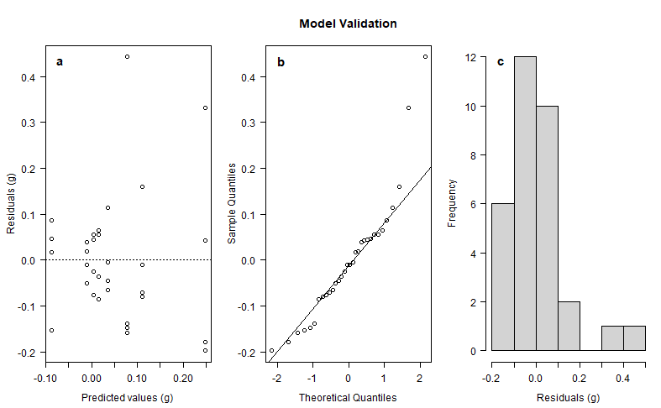

Figure 8: Standard model validation for the ANOVA model for size growth difference (cm) of urchins under different dietary and temperature treatments between T0 and T1. a) Scatterplot of the residuals versus the predicted values to check for similar variances, b) QQ plot of the residuals to check for normality, c) Histogram of the residuals to check for a normal distribution

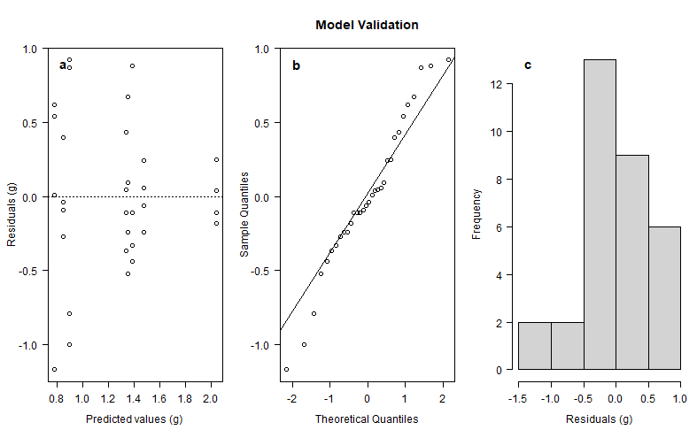

Figure 9: Standard model validation for the ANOVA model for weight gain difference (g) of urchins under different dietary and temperature treatments between T1 and T2. a) Scatterplot of the residuals versus the predicted values to check for similar variances, b) QQ plot of the residuals to check for normality, c) Histogram of the residuals to check for a normal distribution

Table 102. Results of a two factor ANOVA testing the differences in weight gain differences (g) of urchins under 4 dietary treatments and 2 temperature treatments between T1 and T2. The sources of variation, the values of their sums of squares (Sum Sq), degrees of freedom (Df) and Mean sums of squares (Mean Sq) are shown, together with the resulting F statistic (F value) and probability (Pr(>F)).

|  |  |  |  |  |  |  |
| --- | --- | --- | --- | --- | --- | --- |
|  | Df | Sum Sq |  | Mean Sq | F value | Pr(>F) |
| Diet | 3 | 3.258 |  | 1.0859 | 3.276 | 0.0384 * |
| Temperature | 1 | 1.114 |  | 0.024 | 0.024 | 0.878 |
| Diet: Temperature | 3 | 0.491 |  | 0.1637 | 0.494 | 0.6900 |
| Residuals | 24 | 7.955 |  | 0.3315 |  |  |

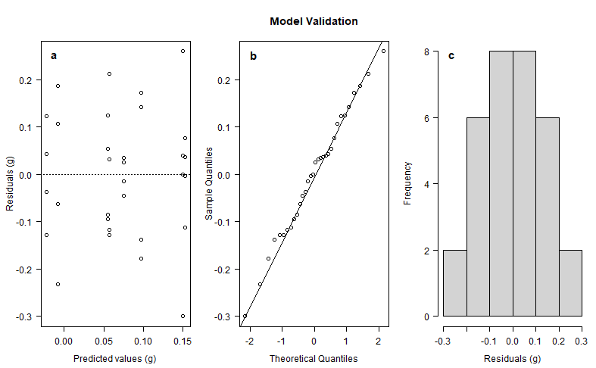

Figure 10: Standard model validation for the ANOVA model for size difference (cm) of urchins under different dietary and temperature treatments between T1 and T2. a) Scatterplot of the residuals versus the predicted values to check for similar variances, b) QQ plot of the residuals to check for normality, c) Histogram of the residuals to check for a normal distribution

Table 102. Results of a two factor ANOVA testing the differences in size growth (cm) of urchins under 4 dietary treatments and 2 temperature treatments between T1 and T2. The sources of variation, the values of their sums of squares (Sum Sq), degrees of freedom (Df) and Mean sums of squares (Mean Sq) are shown, together with the resulting F statistic (F value) and probability (Pr(>F)).

|  |  |  |  |  |  |  |
| --- | --- | --- | --- | --- | --- | --- |
|  | Df | Sum Sq |  | Mean Sq | F value | Pr(>F) |
| Diet | 3 | 0.0312 |  | 0.01039 | 0.467 | 0.708 |
| Temperature | 1 | 0.0259 |  | 0.02588 | 1.163 | 0.292 |
| Diet: Temperature | 3 | 0.0587 |  | 0.01956 | 0.879 | 0.466 |
| Residuals | 24 | 0.5342 |  | 0.02226 |  |  |

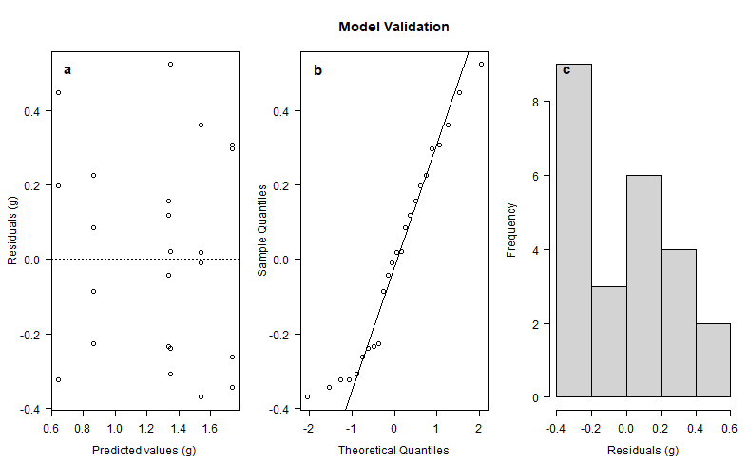

Figure 11: Standard model validation for the ANOVA model for weight gain difference (g) of urchins under different dietary and temperature treatments between T2 and T3. a) Scatterplot of the residuals versus the predicted values to check for similar variances, b) QQ plot of the residuals to check for normality, c) Histogram of the residuals to check for a normal distribution

Table 103. Results of a two factor ANOVA testing the differences in weight gain differences (g) of urchins under 3 dietary treatments and 2 temperature treatments between T2 and T3. The sources of variation, the values of their sums of squares (Sum Sq), degrees of freedom (Df) and Mean sums of squares (Mean Sq) are shown, together with the resulting F statistic (F value) and probability (Pr(>F)).

|  |  |  |  |  |  |  |
| --- | --- | --- | --- | --- | --- | --- |
|  | Df | Sum Sq |  | Mean Sq | F value | Pr(>F) |
| Diet | 2 | 1.2410 |  | 0.6205 | 6.501 | 0.00750 ** |
| Temperature | 1 | 2.0417 |  | 2.0417 | 21.389 | 0.00021 *** |
| Diet: Temperature | 2 | 0.1182 |  | 0.0591 | 0.619 | 0.54940 |
| Residuals | 18 | 1.7182 |  | 0.0955 |  |  |

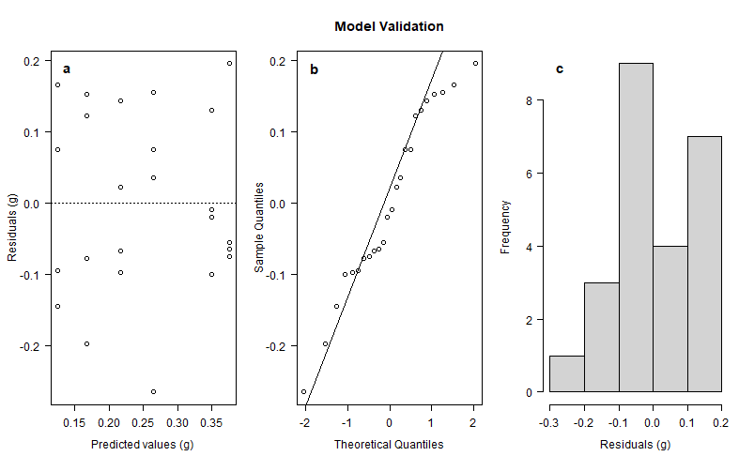

Figure 12: Standard model validation for the ANOVA model for size growth (cm) of urchins under different dietary and temperature treatments between T2 and T3. a) Scatterplot of the residuals versus the predicted values to check for similar variances, b) QQ plot of the residuals to check for normality, c) Histogram of the residuals to check for a normal distribution

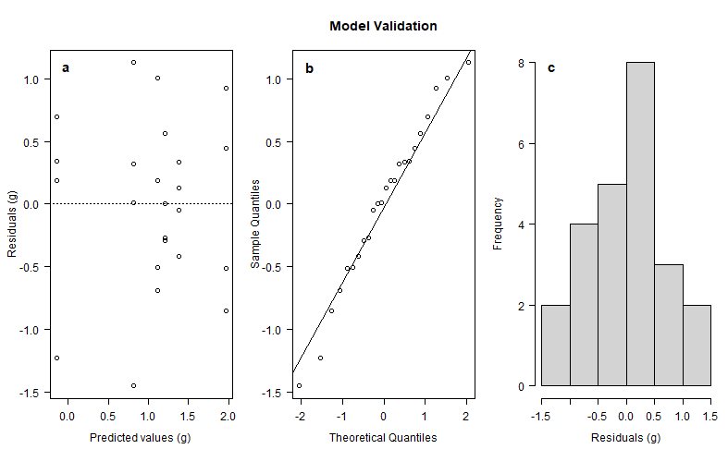

Figure 9: Standard model validation for the ANOVA model for weight gain difference (g) of urchins under different dietary and temperature treatments between T3 and T4. a) Scatterplot of the residuals versus the predicted values to check for similar variances, b) QQ plot of the residuals to check for normality, c) Histogram of the residuals to check for a normal distribution

Table 104. Results of a two factor ANOVA testing the differences in weight gain differences (g) of urchins under 3 dietary treatments and 2 temperature treatments between T3 and T4. The sources of variation, the values of their sums of squares (Sum Sq), degrees of freedom (Df) and Mean sums of squares (Mean Sq) are shown, together with the resulting F statistic (F value) and probability (Pr(>F)).

|  |  |  |  |  |  |  |
| --- | --- | --- | --- | --- | --- | --- |
|  | Df | Sum Sq |  | Mean Sq | F value | Pr(>F) |
| Diet | 2 | 7.327 |  | 3.664 | 6.450 | 0.00772 ** |
| Temperature | 1 | 1.782 |  | 1.782 | 3.138 | 0.09343 |
| Diet: Temperature | 2 | 0.743 |  | 0.372 | 0.654 | 0.53173 |
| Residuals | 18 | 10.224 |  | 0.568 |  |  |

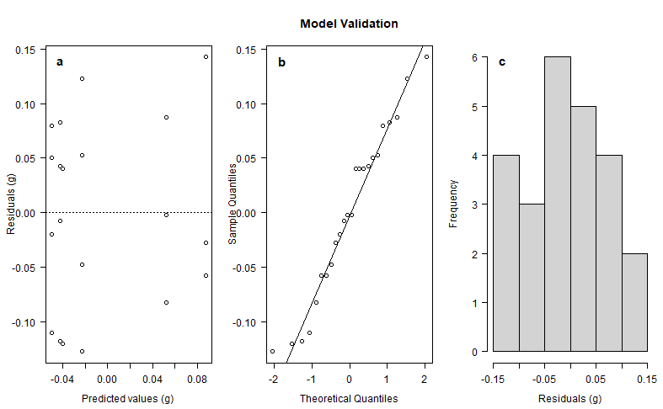

Figure 13: Standard model validation for the ANOVA model size growth (cm) of urchins under different dietary and temperature treatments between T3 and T4. a) Scatterplot of the residuals versus the predicted values to check for similar variances, b) QQ plot of the residuals to check for normality, c) Histogram of the residuals to check for a normal distribution

Table 104. Results of a two factor ANOVA testing the differences in size growth (cm) of urchins under 3 dietary treatments and 2 temperature treatments between T3 and T4. The sources of variation, the values of their sums of squares (Sum Sq), degrees of freedom (Df) and Mean sums of squares (Mean Sq) are shown, together with the resulting F statistic (F value) and probability (Pr(>F)).

|  |  |  |  |  |  |  |
| --- | --- | --- | --- | --- | --- | --- |
|  | Df | Sum Sq |  | Mean Sq | F value | Pr(>F) |
| Diet | 2 | 0.06398 |  | 0.03199 | 4.069 | 0.0348 * |
| Temperature | 1 | 0.00135 |  | 0.00135 | 0.172 | 0.6835 |
| Diet: Temperature | 2 | 0.00183 |  | 0.00091 | 0.116 | 0.8911 |
| Residuals | 18 | 0.14150 |  | 0.00786 |  |  |

NEW

Size SGR table

|  |  |  |  |  |  |  |  |
| --- | --- | --- | --- | --- | --- | --- | --- |
| tank | diet | temperature | treatment | s_growth1 | s_growth2 | s_growth3 | s_growth4 |
| 1 | formulated | warm | fw | 0.03 | -0.15 | 0.25 | -0.05 |
| 2 | mixed | warm | mw | 0 | 0.04 | 0.21 | 0.02 |
| 3 | formulated | ambient | fa | 0.57 | 0.03 | 0.12 | -0.04 |
| 4 | mixed | ambient | ma | 0.11 | 0.02 | 0.27 | 0 |
| 5 | mixed | warm | mw | -0.25 | 0.24 | 0.29 | 0.07 |
| 6 | ulva | warm | uw | 0.07 | -0.08 | 0.28 | 0.04 |
| 7 | kelp | ambient | ka | -0.02 | -0.08 | 0 | 0 |
| 8 | ulva | ambient | ua | 0.15 | 0.17 | 0 | 0.1 |
| 9 | ulva | warm | uw | -0.07 | 0.27 | -0.03 | 0.18 |
| 10 | kelp | warm | kw | -0.06 | 0.19 | 0 | 0 |
| 11 | kelp | ambient | ka | 0.06 | -0.06 | 0 | 0 |
| 12 | formulated | ambient | fa | 0.3 | 0.1 | 0.1 | 0 |
| 13 | formulated | warm | fw | -0.02 | 0.17 | -0.02 | 0 |
| 14 | mixed | warm | mw | -0.08 | 0.2 | 0.42 | -0.11 |
| 15 | ulva | ambient | ua | 0.03 | 0.12 | 0.28 | 0.04 |
| 16 | mixed | ambient | ma | 0.04 | 0.1 | 0.27 | 0 |
| 17 | ulva | warm | uw | 0.08 | 0.24 | 0.08 | 0.02 |
| 18 | kelp | warm | kw | -0.08 | 0.11 | 0 | 0 |
| 19 | formulated | ambient | fa | 0.05 | 0.11 | 0.21 | 0.03 |
| 20 | kelp | ambient | ka | 0.05 | 0.09 | 0 | 0 |
| 21 | kelp | warm | kw | -0.08 | -0.07 | 0 | 0 |
| 22 | ulva | warm | uw | -0.02 | -0.04 | 0.25 | 0.02 |
| 23 | mixed | ambient | ma | 0.28 | -0.06 | 0.49 | -0.11 |
| 24 | formulated | ambient | fa | 0.07 | 0.06 | 0.3 | -0.12 |
| 25 | mixed | warm | mw | -0.04 | 0.16 | 0.3 | -0.05 |
| 26 | formulated | warm | fw | -0.06 | 0.15 | 0.17 | -0.12 |
| 27 | ulva | ambient | ua | -0.01 | -0.04 | 0.36 | 0.04 |
| 28 | ulva | ambient | ua | -0.03 | -0.03 | 0.3 | -0.02 |
| 29 | kelp | warm | kw | 0.53 | -0.23 | 0 | 0 |
| 30 | formulated | warm | fw | 0.01 | 0.39 | 0.02 | 0.02 |
| 31 | mixed | ambient | ma | 0.03 | -0.15 | 0.29 | 0 |
| 32 | kelp | ambient | ka | -0.07 | 0.25 | 0 | 0 |

Weight SGR

|  |  |  |  |  |  |  |  |
| --- | --- | --- | --- | --- | --- | --- | --- |
| tank | diet | temperature | treatment | w_growth1 | w_growth2 | w_growth3 | w_growth4 |
| 1 | formulated | warm | fw | 0.24 | 0.2 | 0.05 | 0.07 |
| 2 | mixed | warm | mw | 0.04 | 0.17 | 0.17 | 0.12 |
| 3 | formulated | ambient | fa | 0.19 | 0.37 | 0.19 | -0.07 |
| 4 | mixed | ambient | ma | 0.09 | 0.34 | 0.36 | 0.4 |
| 5 | mixed | warm | mw | 0.12 | 0.23 | 0.3 | 0.2 |
| 6 | ulva | warm | uw | 0.18 | 0.23 | 0.15 | 0.28 |
| 7 | kelp | ambient | ka | 0.02 | -0.02 | 0 | 0 |
| 8 | ulva | ambient | ua | 0.07 | 0.19 | 0.23 | 0.15 |
| 9 | ulva | warm | uw | 0.07 | 0.12 | 0.19 | 0.09 |
| 10 | kelp | warm | kw | -0.14 | 0.19 | 0 | 0 |
| 11 | kelp | ambient | ka | -0.08 | 0.02 | 0 | 0 |
| 12 | formulated | ambient | fa | 0.32 | 0.37 | 0.21 | 0.11 |
| 13 | formulated | warm | fw | 0.14 | 0.12 | 0.04 | 0.02 |
| 14 | mixed | warm | mw | 0.11 | 0.29 | 0.19 | 0.25 |
| 15 | ulva | ambient | ua | 0.05 | 0.3 | 0.31 | 0.28 |
| 16 | mixed | ambient | ma | 0.15 | 0.39 | 0.26 | 0.22 |
| 17 | ulva | warm | uw | 0.12 | 0.16 | 0.14 | 0.19 |
| 18 | kelp | warm | kw | -0.2 | 0.31 | 0 | 0 |
| 19 | formulated | ambient | fa | 0.24 | 0.37 | 0.23 | 0.25 |
| 20 | kelp | ambient | ka | 0 | 0.3 | 0 | 0 |
| 21 | kelp | warm | kw | -0.01 | -0.08 | 0 | 0 |
| 22 | ulva | warm | uw | 0.19 | 0.14 | 0.1 | 0.05 |
| 23 | mixed | ambient | ma | 0.07 | 0.28 | 0.33 | 0.31 |
| 24 | formulated | ambient | fa | 0.21 | 0.38 | 0.17 | 0.15 |
| 25 | mixed | warm | mw | 0.11 | 0.34 | 0.22 | 0.18 |
| 26 | formulated | warm | fw | 0.23 | 0.26 | 0.13 | -0.19 |
| 27 | ulva | ambient | ua | 0.01 | 0.43 | 0.29 | 0.12 |
| 28 | ulva | ambient | ua | 0.08 | 0.17 | 0.18 | 0.12 |
| 29 | kelp | warm | kw | -0.07 | 0.29 | 0 | 0 |
| 30 | formulated | warm | fw | 0.19 | 0.34 | 0.15 | 0 |
| 31 | mixed | ambient | ma | 0.19 | 0.26 | 0.26 | 0.16 |
| 32 | kelp | ambient | ka | -0.07 | 0.31 | 0 | 0 |

* SIZE TABLES
* SIZE GROWTH TABLES
* FEEDING RATE TABLES
* FCR TABLES
* GSI TABLES